ORIGINAL ARTICLE
Year : 2015 | Volume : 8 | Issue : 3 | Page : 316-319

Nebulized versus intravenous fentanyl for postoperative analgesia after unilateral arthroscopic anterior cruciate ligament reconstruction surgery: a prospective, randomized, comparative trial
Ahmed M Abd El-Hamid MD , Mohamed AI Elrabeie, Ehab E Afifi
Department of Anesthesia and ICU, Faculty of Medicine, Benha University, Benha, Egypt
Date of Submission | 21-Mar-2015
Date of Acceptance | 29-Apr-2015
Date of Web Publication | 29-Jul-2015

Correspondence Address:
Ahmed M Abd El-Hamid
20 Ezz Eldin Omar Street, Elharam, Giza, 12111
Egypt
Source of Support: None, Conflict of Interest: None
DOI: 10.4103/1687-7934.161691
Abstract
Objectives
This study aimed to compare the effect of nebulized fentanyl with intravenous fentanyl for postoperative analgesia after unilateral arthroscopic anterior cruciate ligament reconstruction surgery.
Patients and methods
A total of 87 patients scheduled for unilateral arthroscopic anterior cruciate ligament reconstruction surgery under regional anesthesia were enrolled in the study and were randomly allocated into two groups. Group IV included 42 patients who received 2 μg/kg of fentanyl intravenously, and Group N included 45 patients who received 4 μg/kg of fentanyl nebulization using a standard ventimask. Both groups received the analgesic drug through either intravenously or nebulization route whenever the patient reported pain for the first time in the postanesthesia care unit that was of a score greater than 4 on the visual analog scale. Observations were made for the onset and duration of analgesia, number of patients who were not relieved of pain even 15 min after analgesia administration, level of sedation using the Ramsay sedation scale, and side effects.
Results
Both groups were similar in terms of demographic characteristics and duration of surgery. The onset of analgesia was significantly delayed in group N in comparison with group IV, whereas the duration of analgesia was significantly longer in group N in comparison with group IV. In group IV, the Ramsay sedation score was the maximum at 5 min. In group N, there was a slow rise in the sedation score, but it was always less than that in group IV. Side effects in group N were less compared with group IV, and the number of patients who developed bradycardia was significantly higher in group IV.
Conclusion
This study showed that nebulization with fentanyl is a good alternative to intravenous fentanyl for adequate postoperative pain relief with fewer side effects.
Keywords: intravenous fentanyl, nebulized fentanyl, postoperative analgesia

How to cite this article:
Abd El-Hamid AM, Elrabeie MA, Afifi EE. Nebulized versus intravenous fentanyl for postoperative analgesia after unilateral arthroscopic anterior cruciate ligament reconstruction surgery: a prospective, randomized, comparative trial. Ain-Shams J Anaesthesiol 2015;8:316-9

How to cite this URL:
Abd El-Hamid AM, Elrabeie MA, Afifi EE. Nebulized versus intravenous fentanyl for postoperative analgesia after unilateral arthroscopic anterior cruciate ligament reconstruction surgery: a prospective, randomized, comparative trial. Ain-Shams J Anaesthesiol [serial online] 2015 [cited 2015 Jul 30];8:316-9. Available from: http://www.asja.eg.net/text.asp?2015/8/3/316/161691

Introduction
Fentanyl is a potent, synthetic opioid analgesic with a rapid onset and short duration of action. It is a strong agonist at the μ-opioid receptors. Fentanyl is the most frequently used opioid in clinical anesthesia today. It was first synthesized in 1960. It is structurally related to the phenylpiperidines and has a clinical potency rate that is 50-100 times greater than that of morphine ^{[1]} .
Intravenous route for fentanyl administration has been the gold standard for anesthesia and analgesia. However, it is often associated with several side effects ^{[2]} . Alternative routes of administration are now available; one of them could be inhalational drug delivery. Fentanyl being highly lipophilic is suitable for use through this route, and inhalational administration could be a new promising noninvasive method for fentanyl administration ^{[3]} . This study aimed to compare the effect of nebulized fentanyl with intravenous fentanyl on postoperative analgesia after unilateral arthroscopic anterior cruciate ligament reconstruction surgery.
Patients and methods
After local ethical committee approval and patient's informed written consent was obtained, this prospective, randomized, comparative, and double-blind clinical trial was conducted on 87 patients of American Society of Anesthesiologists I or II between 18 and 56 years of age. All patients underwent unilateral arthroscopic anterior cruciate ligament reconstruction surgery under regional anesthesia.
Patients with morbid obesity (BMI >30), respiratory diseases, hepatic and/or renal diseases, coagulation disorders, pregnant or breast feeding women, uncooperative patients, patients with hypersensitivity to opioids, patients taking other narcotic pain medicines (e.g. morphine, codeine) on a regular schedule or those taking drugs that may interfere with the action of fentanyl (e.g. sibutramine, sodium oxybate, or monoamine oxidase inhibitor) were excluded from the study.
These patients were randomly allocated using the sealed envelope method into two groups.
Group IV included 42 patients who received 2 μg/kg of fentanyl diluted in 10 ml of normal saline 0.9% intravenously along with 5 ml of normal saline 0.9% nebulized using a standard ventimask at a constant flow rate of oxygen at 8-10 l/min for 10 min.
Group N included 45 patients who received 10 ml of normal saline 0.9% intravenously along with 4 μg/kg of fentanyl in 5 ml of normal saline 0.9% nebulized using a standard ventimask at a constant flow rate of oxygen at 8-10 l/min for 10 min.
Both groups received spinal anesthesia with 12.5 mg bupivacaine through a 25 G spinal needle. The block level was between T8 and T10.
Both groups received the analgesic drug through either intravenous or nebulization routes whenever the patient reported pain for the first time in the postanesthesia care unit that was of a score greater than 4 on the visual analog scale (VAS).
The following parameters were recorded:
- Duration of analgesia (primary outcome): The time from the completion of analgesia until the patient's second request of analgesia.
- Onset of analgesia: the time from the completion of analgesia (intravenous or nebulization) until VAS became equal or less than 2.
- Duration of surgery: The time from skin incision until removal of surgical drapes.
- Number of patients who were not relieved of pain even after 15 min of analgesia administration (VAS>4). These patients received diclofenac sodium 75 mg intramuscularly.
- Level of sedation using the Ramsay sedation scale [Table 1] was recorded initially every 5 min up to 30 min, and then at intervals of 15 min up to 2 h.
- Side effects:

Table 1: Ramsay sedation scale [4]
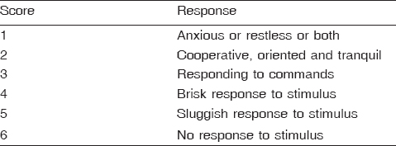

  - Nausea and vomiting.
  - Bradycardia (heart rate < 60/min).
  - Respiratory depression (respiratory rate < 8 min).
  - Hypotension (mean arterial pressure <50).
  - Pruritus.
  - Bronchospasm.
Statistical analysis
Data were managed using SPSS (IBM, New York, USA), version 16. Quantitative data were presented as mean and SD and were analyzed using the Student t-test. Qualitative data were presented as number of patients and percentages and were analyzed using the χ²and Z-tests. Ramsay sedation scores were presented as median and interquartile range and were analyzed using the Mann-Whitney U-test. A P-value less than 0.05 was considered to be statistically significant, whereas a P-value less than 0.01 was considered to be statistically highly significant. Sample size was estimated according to a pilot study for the first 10 patients in each group by assuming α error = 0.05 (two tailed) and a power of 80% to detect an assumed clinically significant difference (effect size d = 0.664) between the paired measurements of the duration of analgesia between the two groups (primary outcome). The t-test for matched pairs was used to estimate the sample size. Thirty-seven patients were estimated in each group.
Results
Both groups were similar in terms of demographic characteristics, duration of surgery, and the number of patients who required analgesia. The onset of analgesia was significantly delayed in group N in comparison with group IV, whereas the duration of analgesia was significantly longer in group N in comparison with group IV [Table 2].

Table 2: Demographic characteristics, duration of surgery, and onset and duration of analgesia
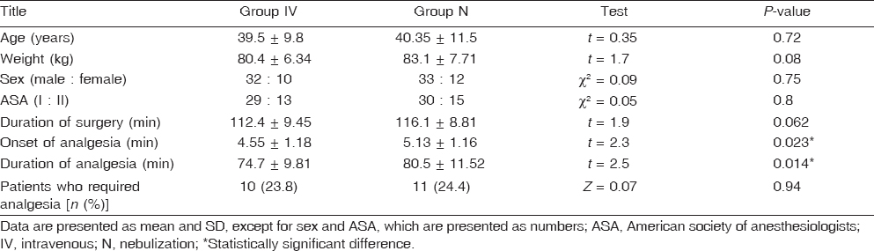
In group IV, the Ramsay sedation score was the maximum at 5 min. In group N, there was a slow rise in the sedation score, but it was always less than that in group IV [Figure 1].
Figure 1: Ramsay sedation scale. Data were represented as median and interquartile range. *Significant; **Highly significant.
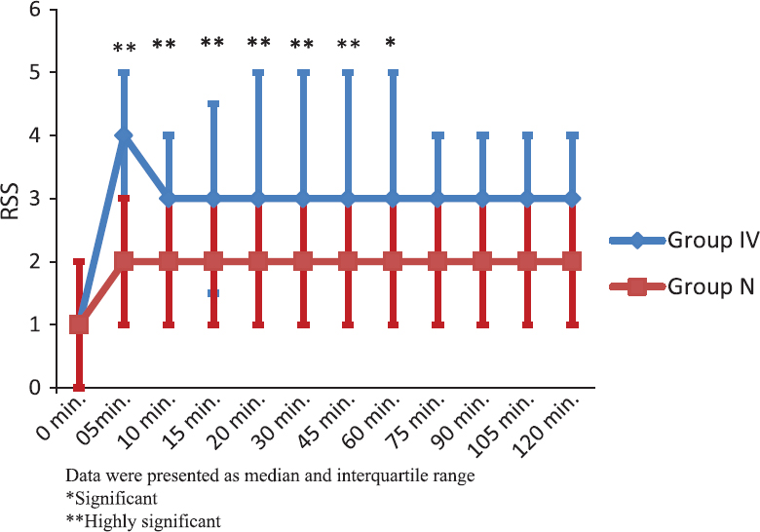

Side effects in group N were less compared with group IV, and the number of patients who developed bradycardia were significantly higher in group IV [Table 3].
Table 3: Comparison between groups as regards side effects
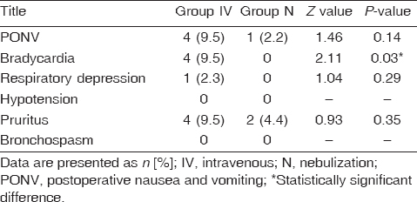

Discussion
The present study compared the effect of fentanyl 2 μg/kg through intravenous route with the effect of fentanyl 4 μg/kg by nebulization on the basis of a study conducted by Singh et al. ^{[2]} , which showed that 4 μg/kg nebulized fentanyl produces pain relief comparable to 2 μg/kg intravenous fentanyl.
The onset of analgesia in the present study showed a significant delay in group N in comparison with group IV, whereas the duration of analgesia was significantly longer in group N in comparison with group IV. Although these differences have no clinical value, nebulization with fentanyl had fewer side effects. This was in accordance with the findings of Singh et al. ^{[2]} and Bartfield et al. ^{[5]} . This was also supported by Kissin ^{[6]} , who found that maximum serum concentration of fentanyl is reached rapidly after intravenous administration compared with intranasal administration. The previous finding also explains the difference in sedation score between the intravenous group and the nebulization group in our study. Side effects were less in group N. This was in accordance with Worsley et al. ^{[3]} and Higgins et al. ^{[7]} . In a study conducted by MacLeod et al. ^{[8]} , they demonstrated that the pharmacokinetic profile of single doses of inhaled fentanyl is comparable to that of intravenous administration.
Farahmand et al. ^{[9]} compared the effectiveness of nebulized fentanyl with intravenous morphine in the management of acute limb pain and suggested that nebulized fentanyl is a rapid, safe, and effective method for temporary control of acute limb pain in emergency department patients. Furyk et al. ^{[10]} also compared the efficacy of nebulized fentanyl with intravenous morphine in pediatric patients presenting to the emergency department with clinically suspected limb fractures and found that nebulized fentanyl at a dose of 4 μg/kg provided a clinically significant improvement in pain scores, comparable to that of intravenous morphine. Several studies ^{[2],[5],[11]} have documented the effectiveness of nebulized fentanyl compared with intravenous fentanyl.
Conclusion
Nebulization with fentanyl is a good alternative to intravenous fentanyl for adequate postoperative pain relief with fewer side effects.
Acknowledgements
Conflicts of interest
None declared.
References

1. | Gourlay GK, Kowalski SR, Plummer JL, Cousins MJ, Armstrong PJ .Fentanyl blood concentration-analgesic response relationship in the treatment of postoperative pain. Anesth Analg 1988; 67:329-337.
2. | Singh AP, Jena SS, Meena RK, Tewari M, Rastogi V. Nebulised fentanyl for post-operative pain relief, a prospective double-blind controlled randomised clinical trial. Indian J Anaesth 2013; 57:583-586.  [PUBMED]
3. | Worsley MH, MacLeod AD, Brodie MJ, Asbury AJ, Clark C. Inhaled fentanyl as a method of analgesia. Anaesthesia 1990; 45:449-451.
4. | Ramsay MA, Savege TM, Simpson BR, Goodwin R. Controlled sedation with alphaxalone-alphadolone. Br Med J 1974; 2:656-659.  [PUBMED]
5. | Bartfield JM, Flint RD, McErlean M, Broderick J. Nebulized fentanyl for relief of abdominal pain. Acad Emerg Med 2003; 10:215-218.
6. | Kissin I. Preemptive analgesia. Anesthesiology 2000; 93:1138-1143.
7. | Higgins MJ, Asbury AJ, Brodie MJ. Inhaled nebulised fentanyl for postoperative analgesia. Anaesthesia 1991; 46:973-976.
8. | Macleod DB, Habib AS, Ikeda K, Spyker DA, Cassella JV, Ho KY, Gan TJ. Inhaled fentanyl aerosol in healthy volunteers: pharmacokinetics and pharmacodynamics. Anesth Analg 2012; 115:1071-1077.
9. | Farahmand S, Shiralizadeh S, Talebian MT, Bagheri-Hariri S, Arbab M, Basirghafouri H, et al. Nebulized fentanyl vs intravenous morphine for ED patients with acute limb pain: a randomized clinical trial. Am J Emerg Med 2014; 32:1011-1015.
10. | Furyk JS, Grabowski WJ, Black LH. Nebulized fentanyl versus intravenous morphine in children with suspected limb fractures in the emergency department: a randomized controlled trial. Emerg Med Australas 2009; 21:203-209.
11. | Miner JR, Kletti C, Herold M, Hubbard D, Biros MH. Randomized clinical trial of nebulized fentanyl citrate versus i.v. fentanyl citrate in children presenting to the emergency department with acute pain. Acad Emerg Med 2007; 14:895-898.

Figures
[Figure 1]
Tables
[Table 1], [Table 2], [Table 3]

